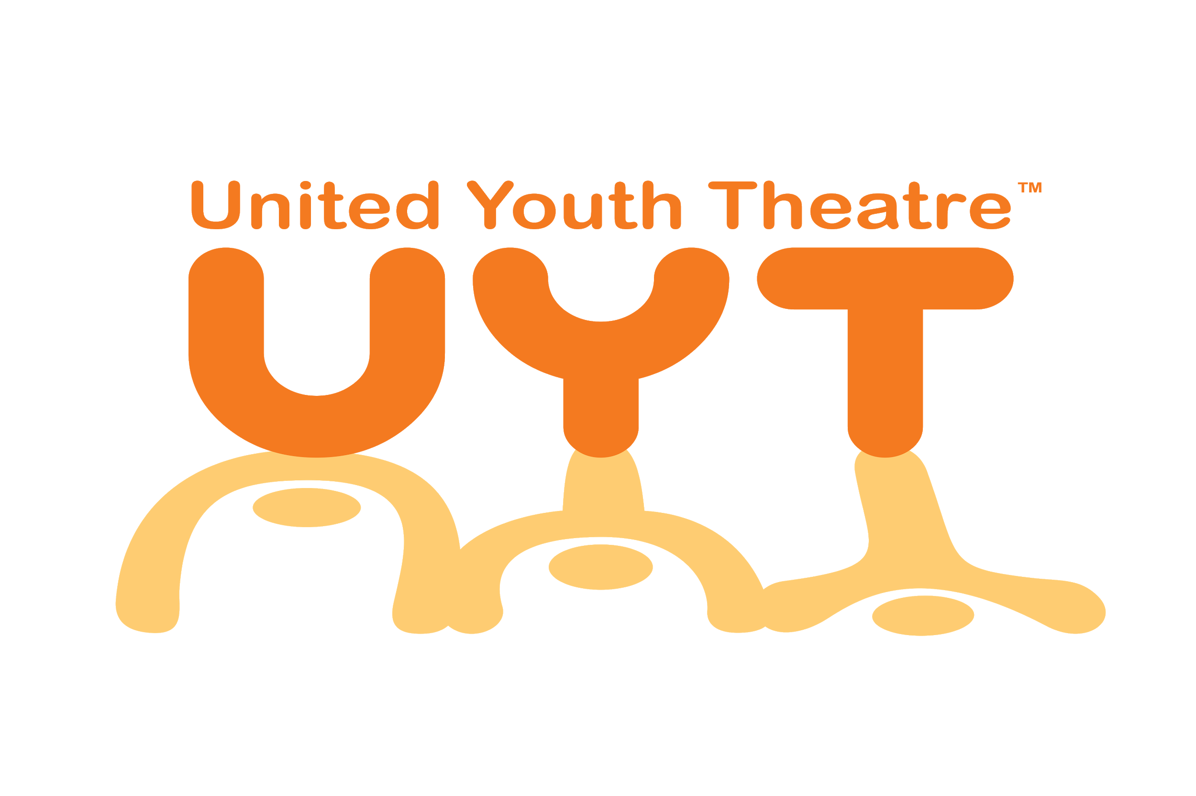
Making a difference by helping EVERY kid gain confidence, foster creativity and develop mutual trust and respect through the arts!

Play in Day Registration Form
Please fill out the information listed below and send this to our PO Box 1143 ND, IN 46656-4623 with payment to register for classes! Hope to see you there!

Student Name:_______________________________________________
Student Age:________________________________________________
Parent Name:________________________________________________
Primary Phone:______________________________________________
Email Address:_______________________________________________
Address:____________________________________________________
City/State/Zip:________________________________________________
Emergency Contact:
Payment Type: ( ) Check ( ) Cash
Allergies/Any Information we should know:______________________________
By checking this, I am allowing my child to be photographed during class and have their image used for promotional purposes for UYT_____________

